|  |  |  |
| --- | --- | --- |
|  |  | w/c 4th January 2021 at  Lindley Group Practice  312.5 |

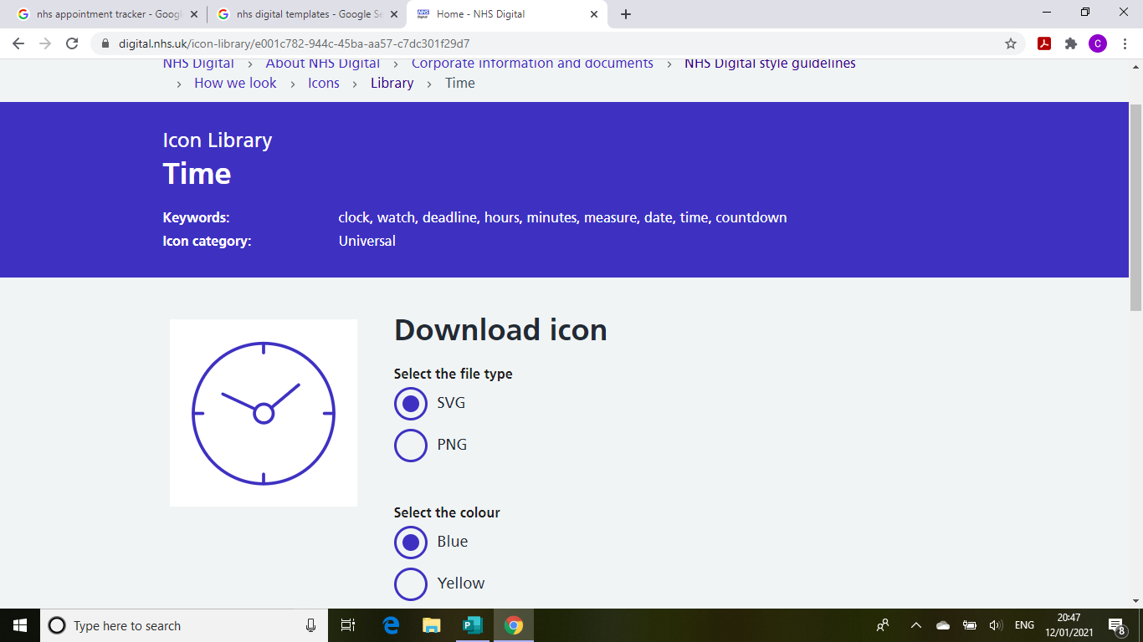

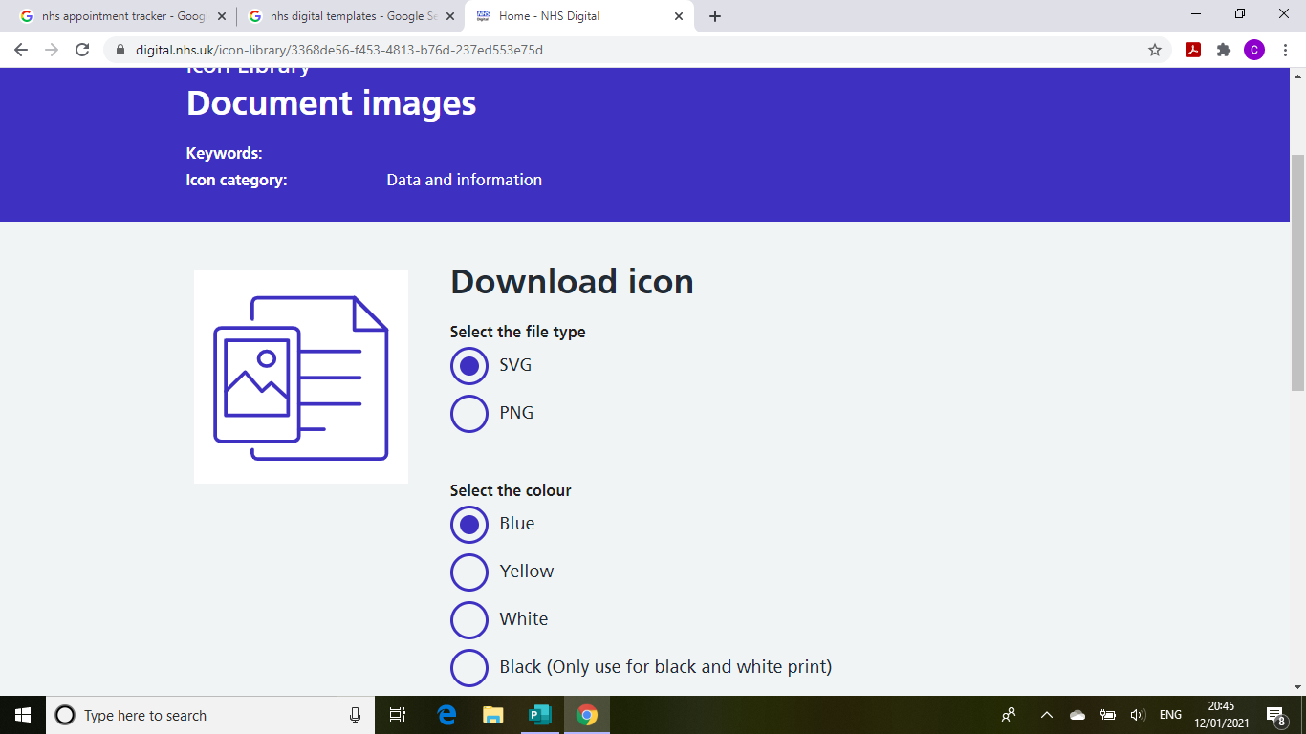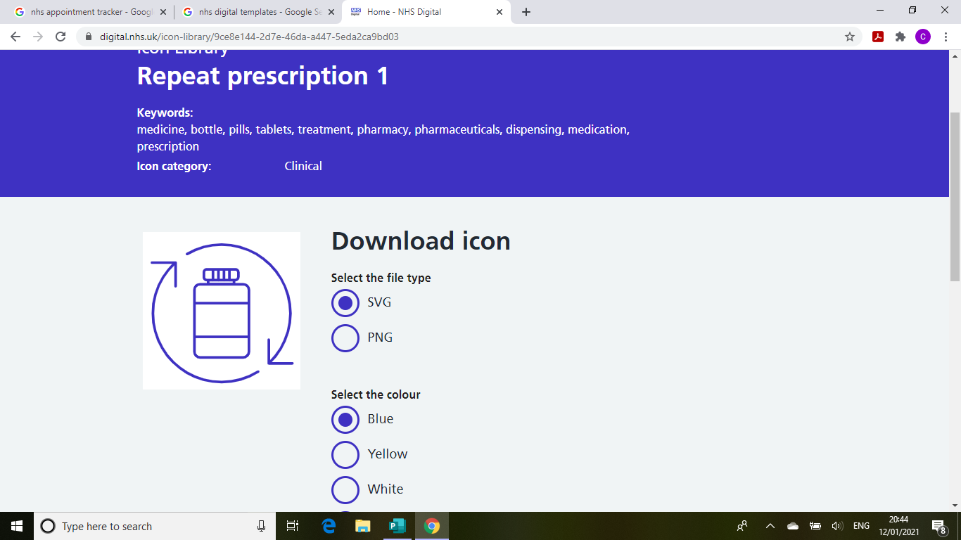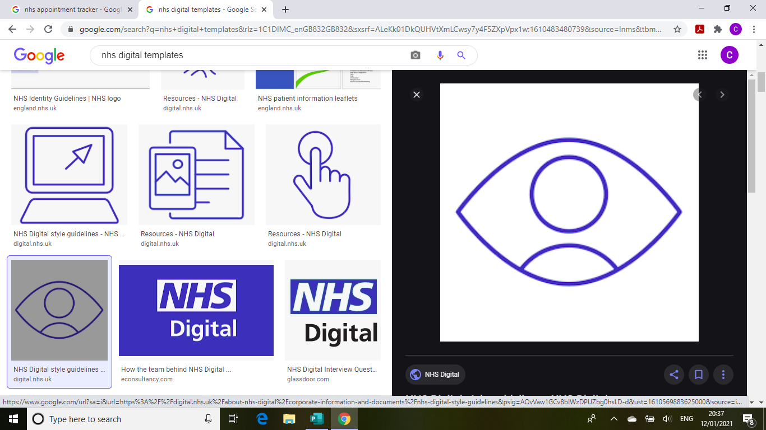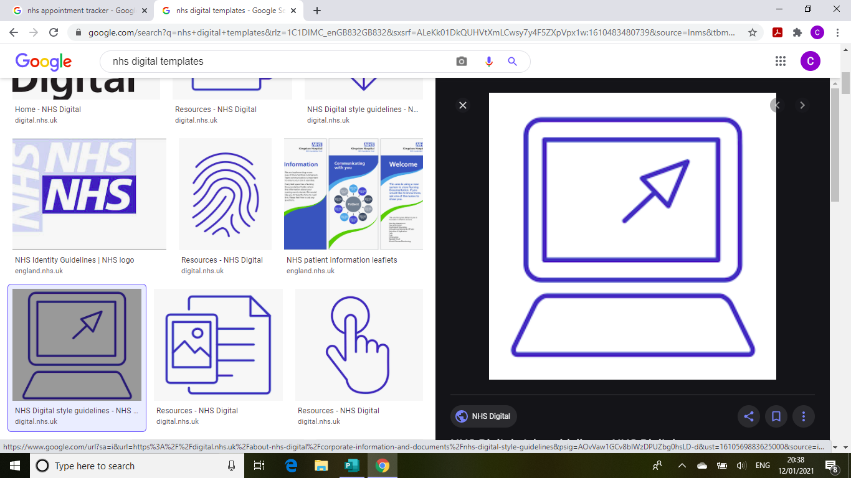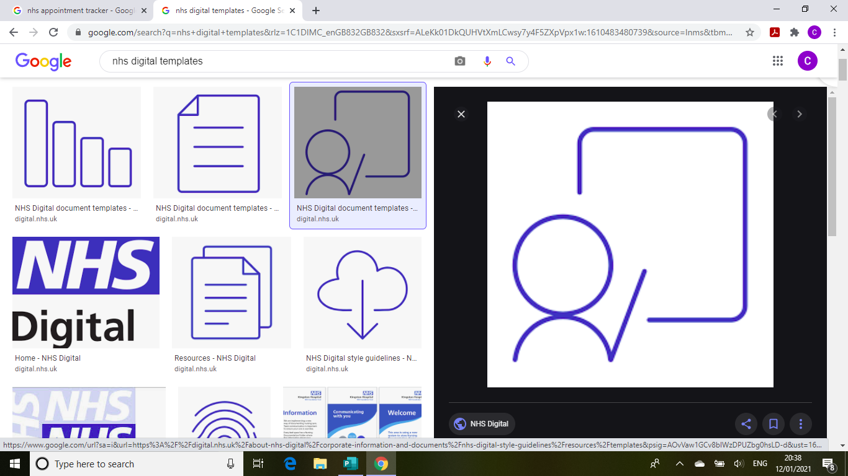

1,445

***Clinical Hours***

550

26

124

593

119

***Prescriptions***

***Documents processed***

***“face-to-face” consultations***

***Telephone consultations***

***eConsultations***

***Meeting hours***